Programming Project 1: Quadtree

1. Task: Destroy the tree

Test | Uniform tree up to level 2 | Non-uniform tree up to level 3(self-defined)
Expected output | Valgrind output of 21 allocs, all free, no errors | Valgrind output of 26 allocs, all free, no errors
Actual output

The function
- Its header file
- The code

2. Task: Grow the tree

Test | Uniform tree up to level 2  (insert tree image here) | Non uniform tree up to level 3  (insert tree image here)
Expected output | Uniform tree up to level 3, all memories freed in valgrind | All node has children add, all memories freed in valgrind
Actual output | 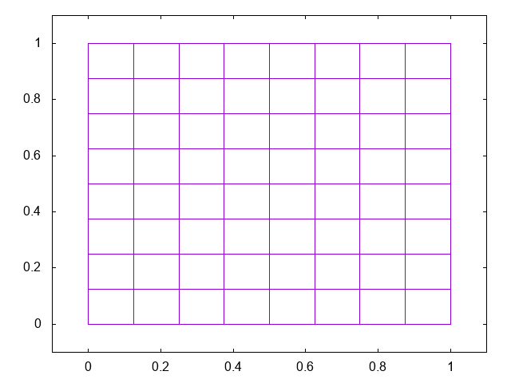 | 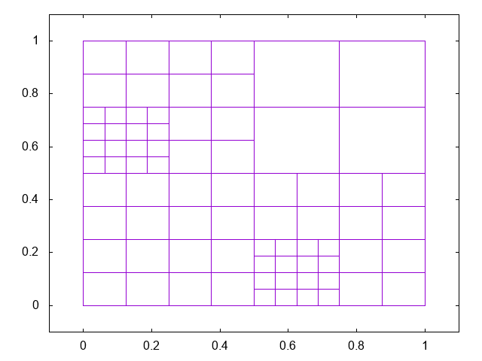
Valgrind

The function
- Its header file
- The code

3. Task: A limit on tree
- A node of tree consist of an integer which is 4 bytes, two doubles with size of 2*8 = 16 bytes, and 4 pointers with size of 8 bytes each, hence 4*8 = 32 bytes . As a results the total size of a node is 4 + 16 + 32 = 52 bytes.
- Calculate the number of nodes (all trees are uniform) by the formula
nodes = [(4^(levels + 1)) -1]/3
because level starts with 0, hence node for a tree up to level 0 is
[4^1 – 1]/3 = 1 node

Levels | Number of nodes(nodes) | Expected memory(bytes)
5 | 1365 | 70,980
6 | 5461 | 283,972
7 | 21,845 | 1,135,940
8 | 87,381 | 4,543,812
9 | 349,525 | 1,817,5300
10 | 1,398,101 | 72,701,252

Levels | Number of nodes(nodes) | Actual memory(bytes)
5 | 1365 | 77,008
6 | 5461 | 306,384
7 | 21,845 | 1,223,888
8 | 87,381 | 4,893,904
9 | 349,525 | 19,573,968
10 | 1,398,101 | 78,294,224

iv. 20Mb = 20 * 2^20 = 20,971,520 bytes. If I would like to limit the memory to 20Mb I will limit the level of the tree up to 9 level maximum, so it would not exceed this level.

v. I have actually implement maxLevel right when I wrote growTree(), but I did specified two different test cases for task 2 and task 3.
Test | Maximum level 3 | Maximum level 4
Expected output
Actual output
Valgrind

4. Task: Generate a data dependent quadtree

Test | Expected output | Actual output
Level 2 tree, choice = 0, tolerance = 0.5 | 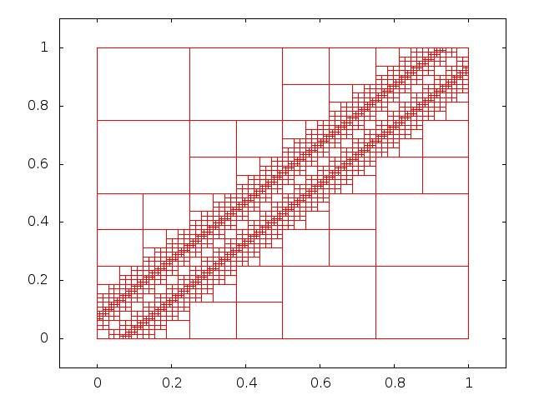  (picture from minerva) | 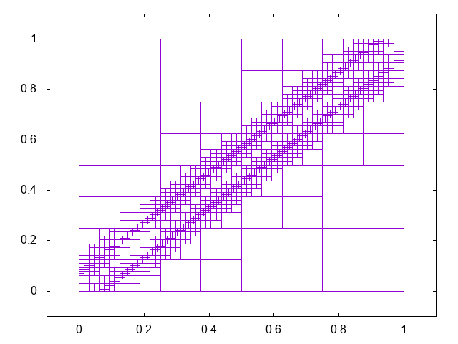
Level 2 tree, choice = 1, tolerance = 0.2 | N/A | 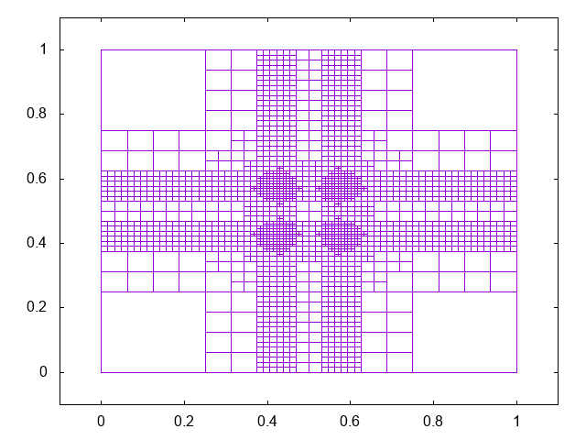

The function
- Its header file
- The code

5. Task: Reflection
- I think the first two task was not too difficult, since I can use a similar algorithm to the writeTree() function.
- The hardest part would be the test files. I have yet to write a test file until this project, and so I struggled a bit to think of the format of the test file

Reference
Quadtree node calculation
https://stackoverflow.com/questions/4846357/finding-size-of-perfect-quad-tree
Code
- Lecture notes, Exercise 4 – 5

